Covid-19 viz via cartograms

Johny Rufus

I590 – Data Visualization

**Introduction** **2**

Motivation 2

Existing Work 4

**Data and Methods** **8**

**Results** **12**

Choropleth time series 12

Non contiguous Cartogram 14

Contiguous cartogram univariate 16

Contiguous cartogram bivariate 19

**Conclusion and Future Work** **21**

**References** **22**

# **Introduction**

## **Motivation**

The impact of COVID-19 also known as the coronavirus, on the life of the people and the economy of the nations has been extremely severe. It is important to study a number of factors related to the disease including but not limited to the spread of the disease, the causal factors, the impact on the economy and a multitude of factors related to how the pandemic is handled and data visualization is an important tool [1, 2] in analyzing the various aspects. Our goal in this project is to create visualizations to better understand the timeline of the coronavirus spread. In particular we would like to focus our efforts on utilizing cartograms to create visualizations and time lapse videos to better understand the spread of the disease in the United States. Cartograms have proven to be effective tools in visualizing geo referenced data [3] and are very good at highlighting the variable being mapped by modifying the size of the area relative to the variable of interest. Using cartograms has resulted in beautiful visualizations that project the variable of interest in a sharp and outstanding manner as illustrated in the Twitter mood visualization project [4] which is from our own Professor and his team.

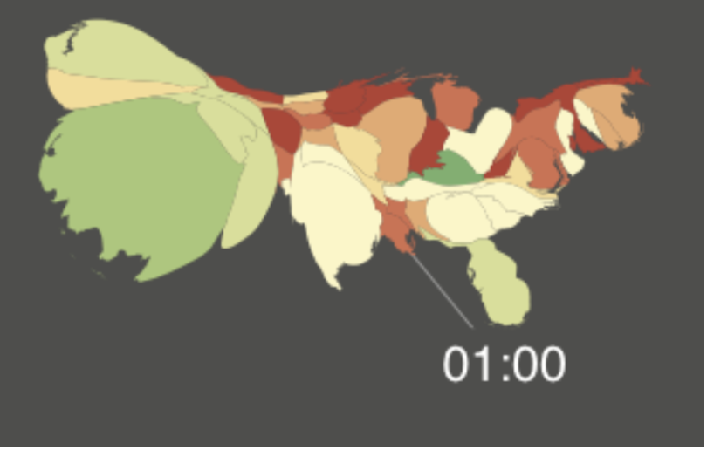

Figure 1: Twitter Mood Visualization

As shown in Figure 1, their work captures the changing mood of the people during various times of the day using the sentiment of the tweets. By using cartograms, they are able to efficiently project the size of the states proportionate to the number of tweets, with the color representing the sentiment of the tweets.

The importance of cartograms in effectively displaying the variable of interest can be very clearly understood from the work done by Newman and Gastner [5] in their work on displaying the 2012 US Presidential election results.

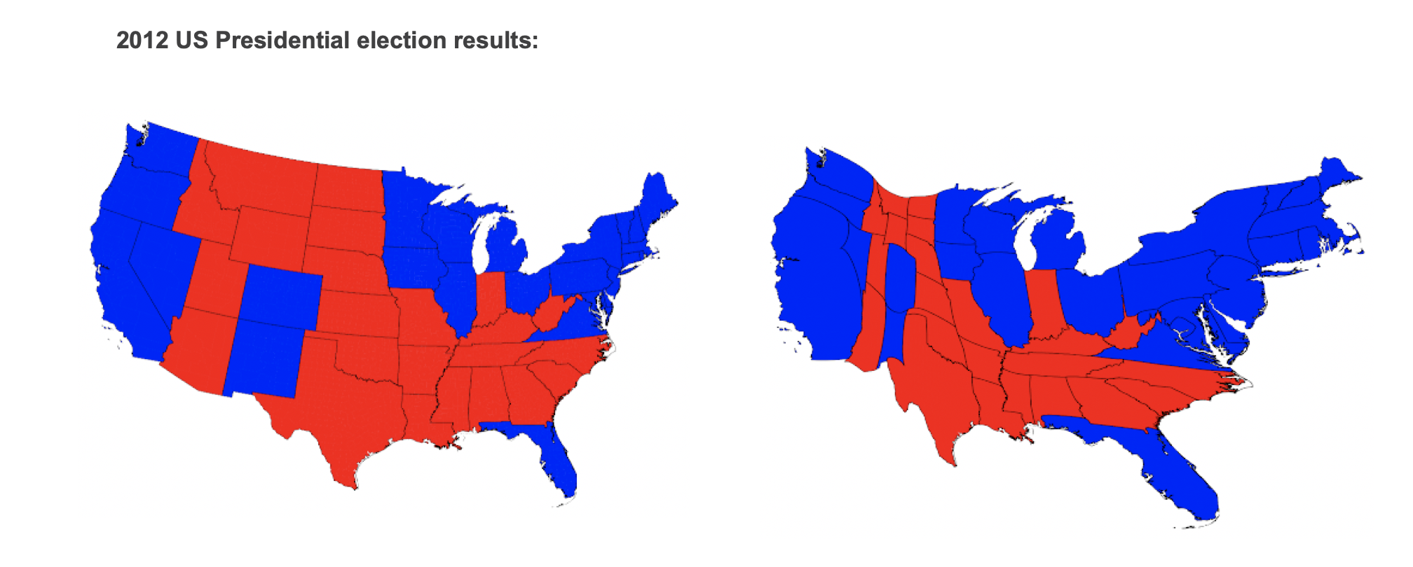

Figure 2: US Presidential election results 2012

As shown in Figure 2, when we look at the results using a normal map as drawn on the left, it looks like the Republicans won the election as there is more red than blue. But as we know that this is not true and the apparent reason behind the paradox is that it fails to take into account the factor that determines the election results, which is not the land acreage but the population represented by the number of electoral votes and blue may be smaller in land area, but it represents more people and electoral votes which is what matters in an election and the map on the right is drawn based on the electoral votes of a state, where the size of a state is resized based on the number of electoral votes and here we can see that blue is the clear winner.

The work done in this paper [6] visualizes the spread of the virus in China using circular graphical based cartograms. While this type of cartogram is helpful, the underlying geography of the region is under-represented. Similarly the visualizations in the worldmapper site [7] represent the cartograms for the entire world for different timelines using an equal population projection.

Many more visualizations have been produced in recent days to visualize the spread of the coronavirus and some of the prominent ones are from nytimes [8] and from the jhu website [9]. Taking inspirations from [4, 7], our goal is two prong. First, we would like to explore the use of cartograms [10] to visualize the number of confirmed cases and deaths in different states of the US. Our idea is to use a single cartogram image, to find a way to better visualize both the confirmed cases and deaths. We can represent the area of a region using the number of confirmed cases and represent the color of the region using the number of deaths. Then, our ultimate goal is to produce a time lapsed video of the maps that  will visualize how the pandemic spread over the course of the last few months. To begin with, we would first like to visualize the data relating to the confirmed cases and deaths in the US using choropleth maps similar to the visualization produced by the nytimes website [8]. Cartograms themselves come in multiple favors [11], and our goal is to experiment with them to find a suitable candidate for the time lapsed video, by first using non contiguous cartograms and finally moving on to diffusion based contiguous cartograms [12].

To summarize, by using different candidate methods like contiguous and non contiguous cartograms and choropleth maps, our ultimate goal is to create visualizations and time lapsed videos that uniquely visualizes the spread of the coronavirus in the United States over the period of its first case to date.

## **Existing Work**

Cartograms are a map visualization technique used mainly to project a specific variable of interest other than the land area of a region, while still maintaining the relative shape of the actual geographical region. There are many different types of cartograms in use today, of which the contiguous cartogram, non-contiguous cartograms and the dorling cartograms being the most popular [11].

The following Figure 3, is a cartogram visualization of the Covid-19 cases from worldmapper [7].

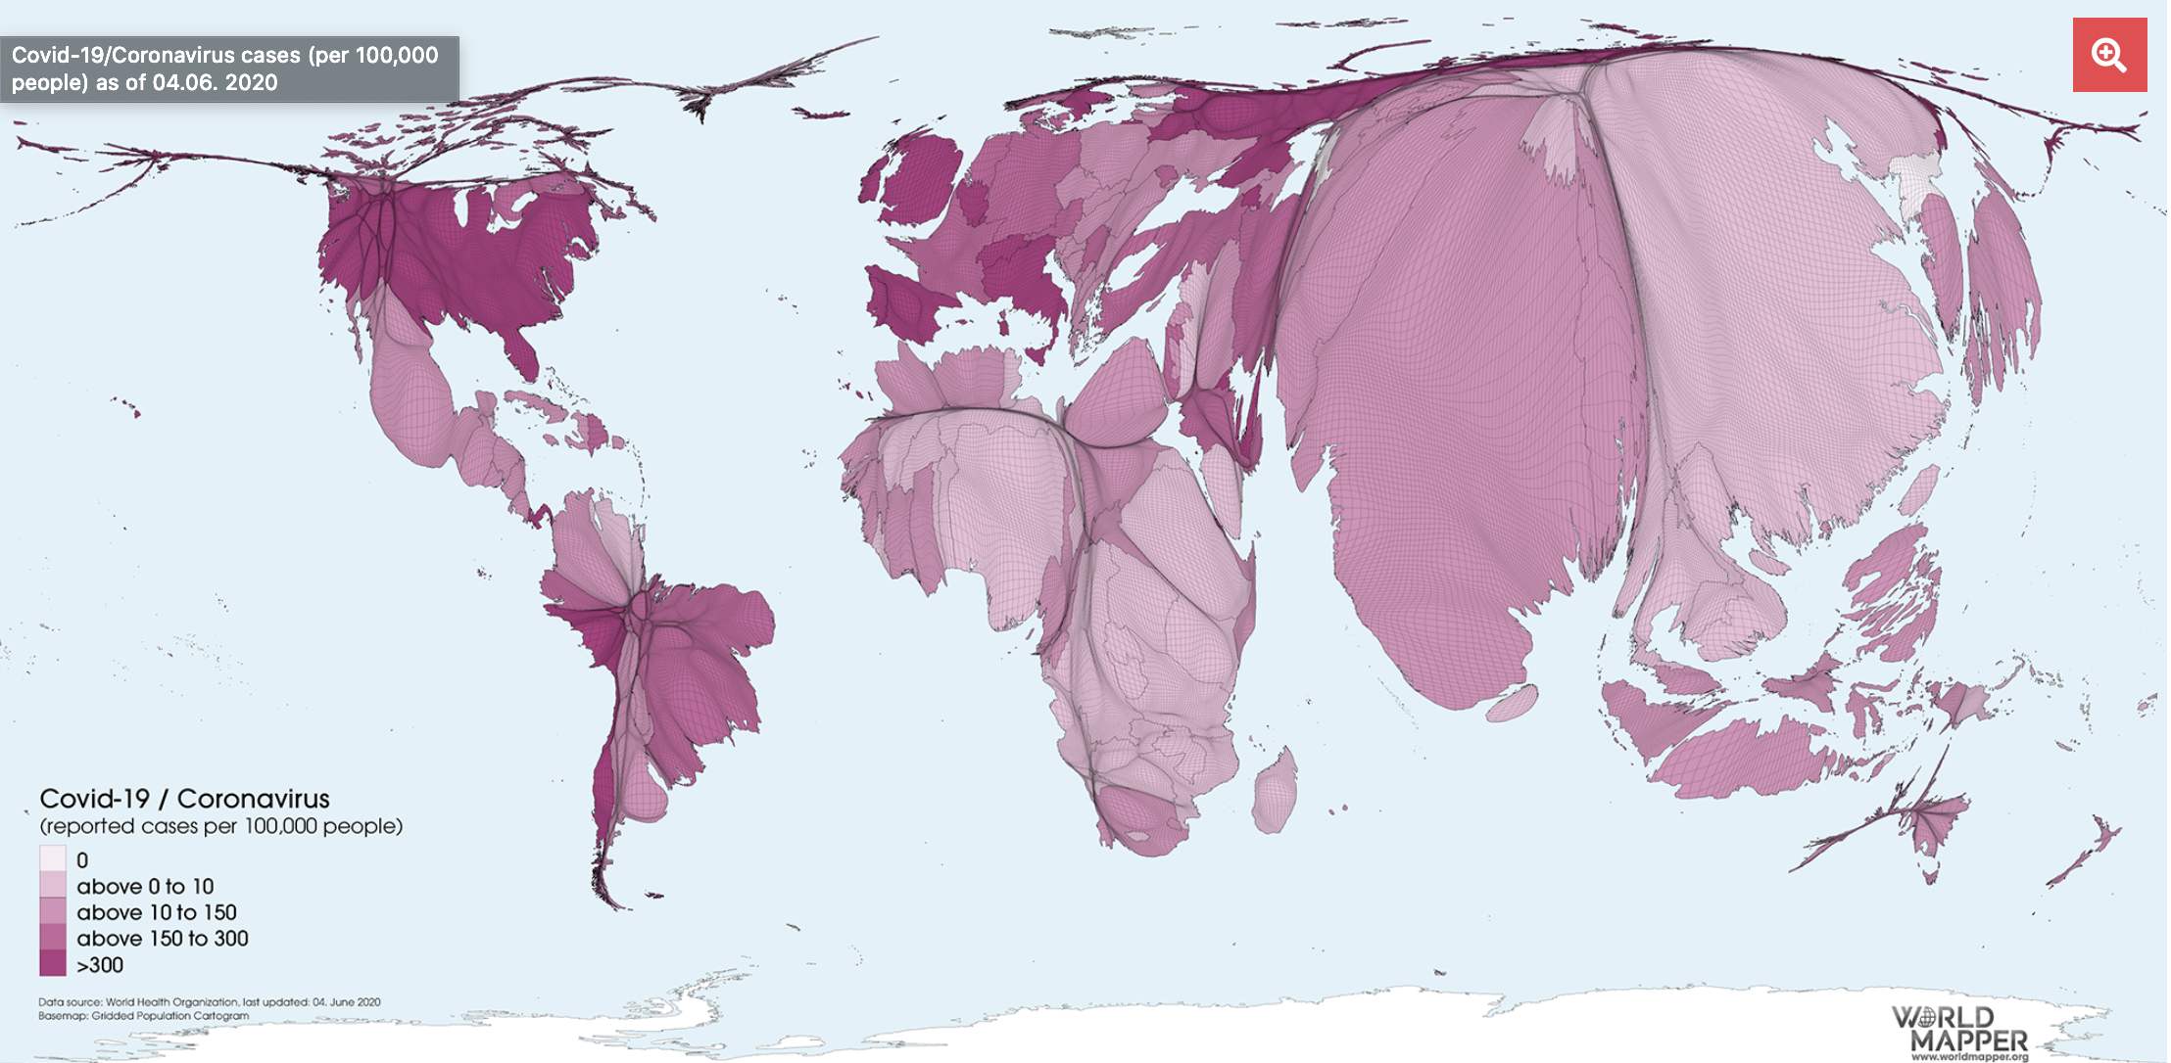

Figure 3: Covid-19 cartogram of the world from worldmapper site

This cartogram resizes the size of a country in proportion to its population and the color scheme represents the number of reported cases per 100k people. They also have a couple of similar visualizations corresponding to the mortality rate. The key strengths of the above visualization is it helps to understand the population that is affected by the coronavirus, rather than the land area. A very notable example to consider from this visualization is how Canada shrinks in size when drawn by its population. Also another notable observation is how the US is relatively smaller when compared to China in terms of its population, but it's more darker in terms of the number of cases, indicating that the infection is more severely affecting the US population than China. The strength of the above visualization lies in exposing the severity of coronavirus in proportion to the population. The main drawback of the visualization is the notable distortion in shape of many countries, thereby making it harder for the viewer to fully explore the visualization without referring to an actual map drawn by its region. Also it is difficult to find the statistics of a specific region as the cartogram is drawn in a non interactive manner.

Another nice animation of a time lapse video of the cartogram for the entire world is shown in the worldmapper page [13]. The cartograms in this visualization resize the area of a region based on the number of cases and the beauty of this visualization is it clearly depicts the flow of the infection, as it starts with January where the entire world is just China as the infection starts and slowly we can see other countries increasing in size. The end of the video shows how well the infection is contained in China, whereas the other countries balloon up in size due to the rapid spread of the infection.

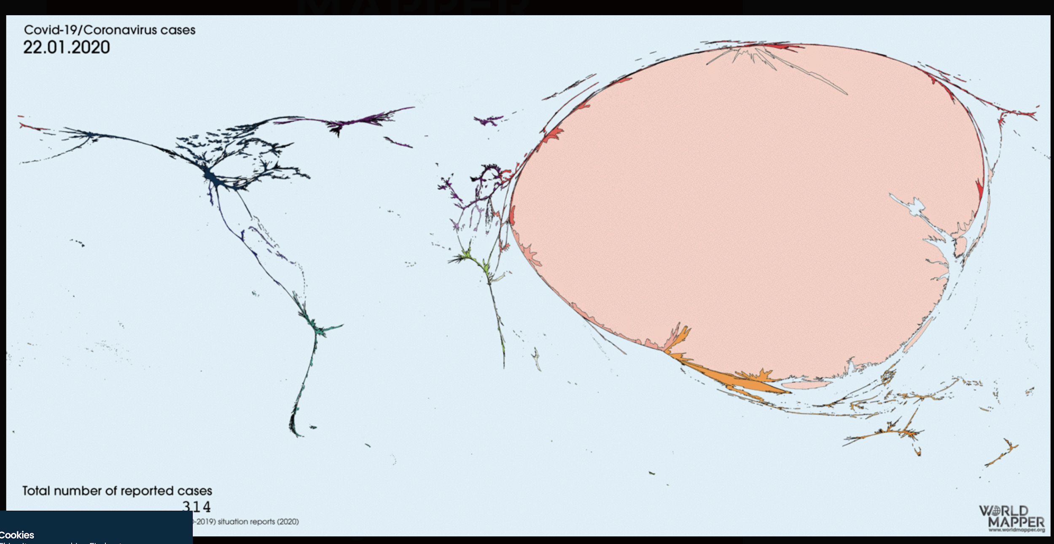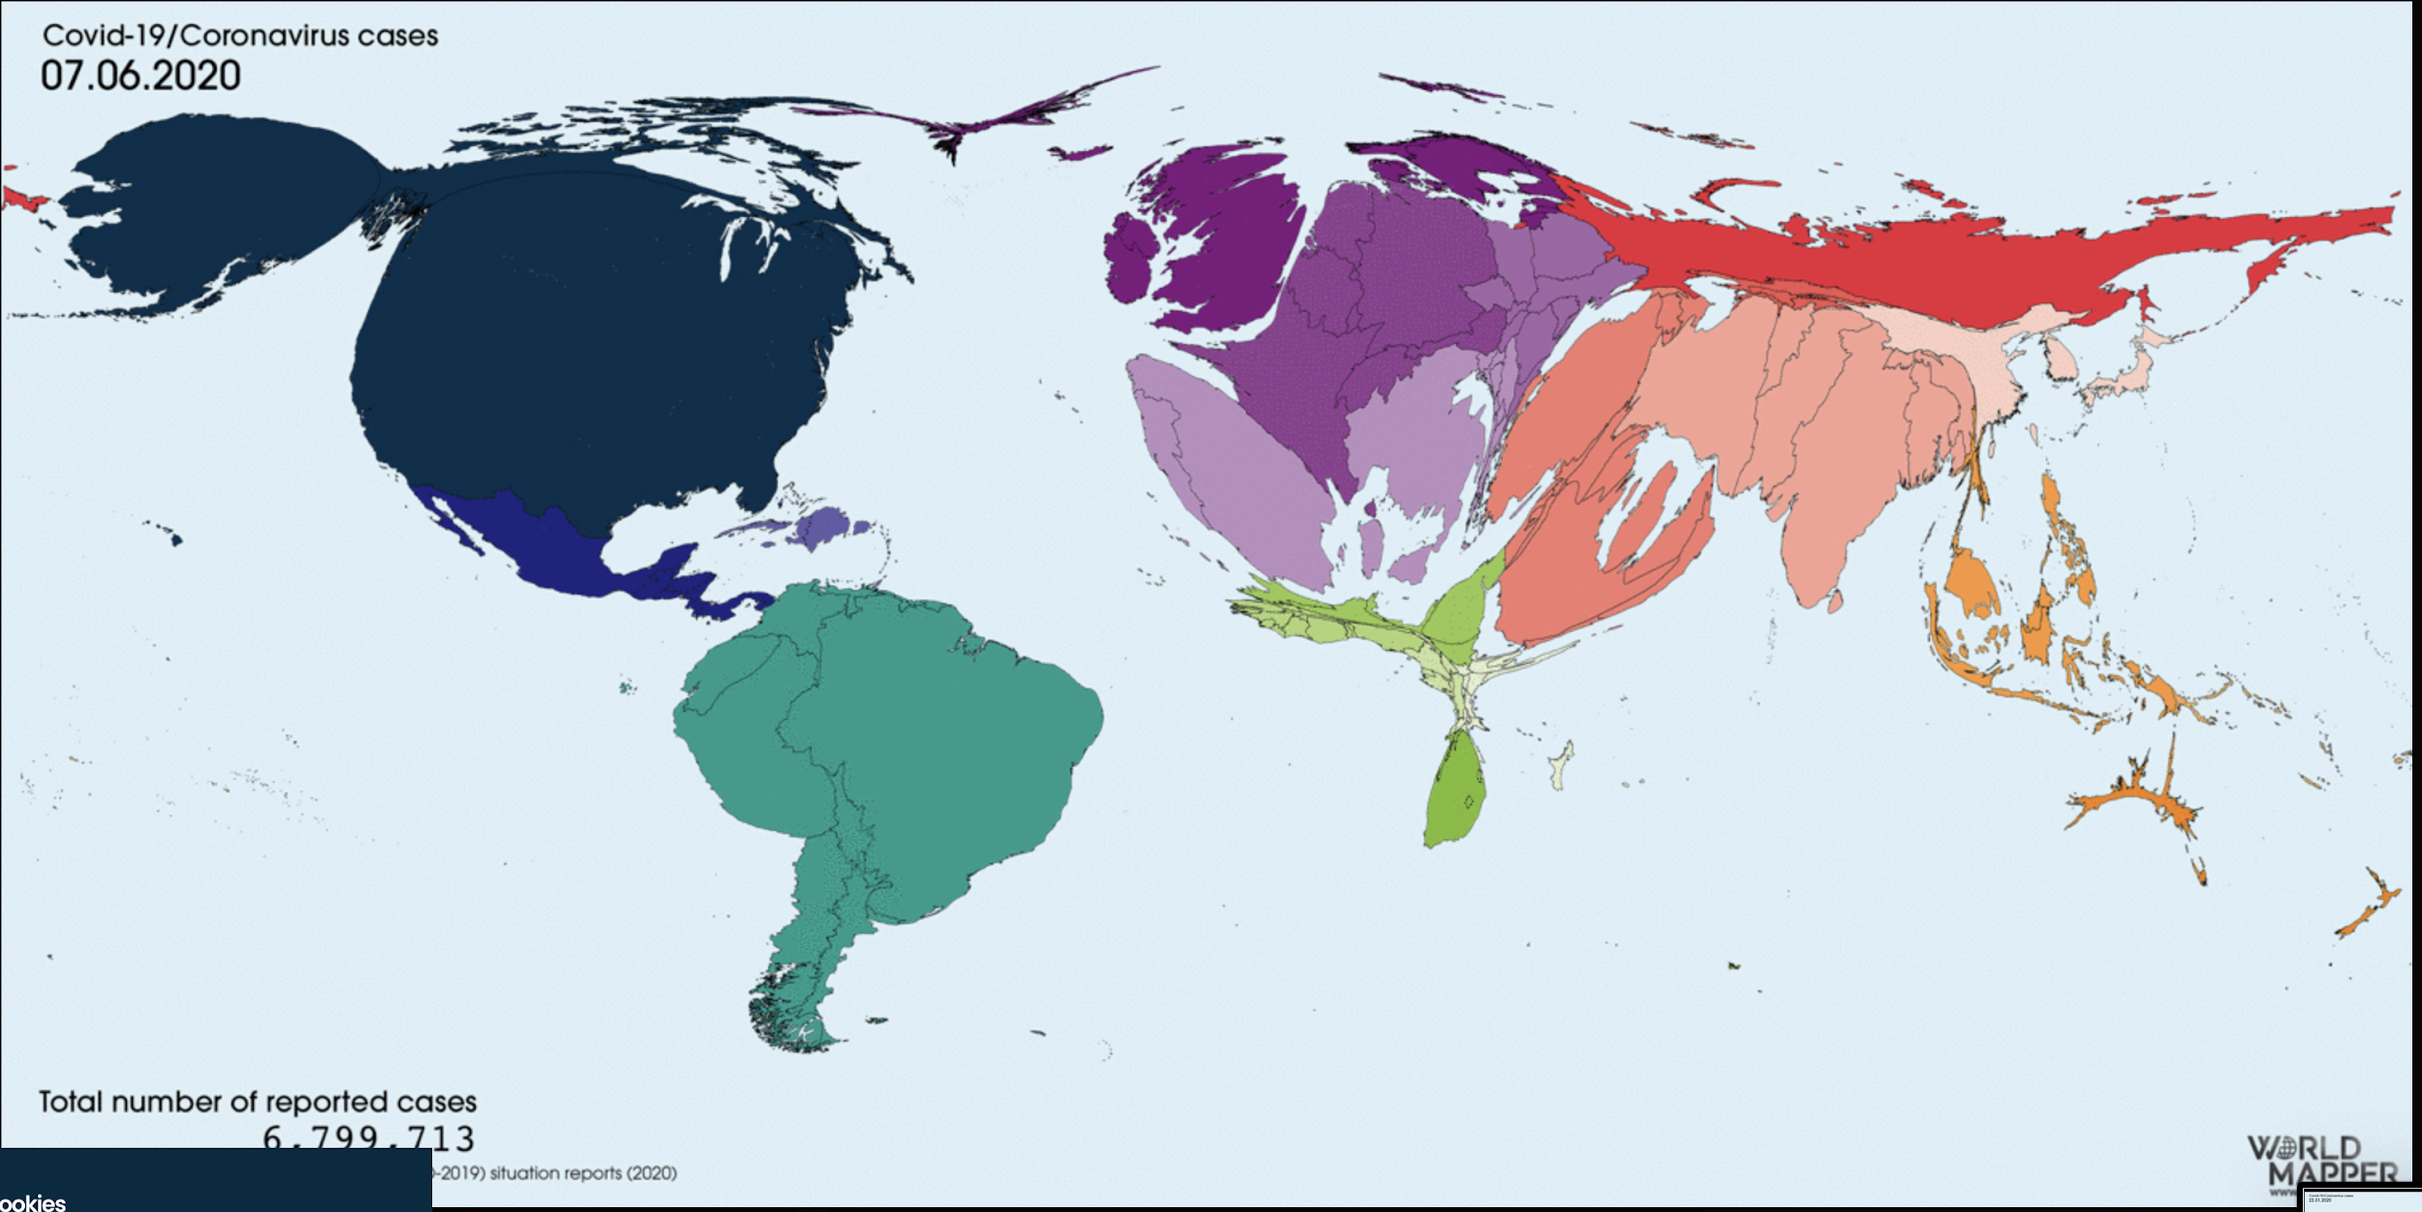

Figure 4: The world represented in proportion to the number of covid-19 cases: Jan 22 2020 vs June 7 2020:

As depicted in Figure 4, the video clearly shows how the virus started and where we are currently in terms of the number of cases of the infection. The main drawback of the timelapse video is again the inability of a cartogram to be interactive, which requires the viewer to put in extra effort to locate a specific country or a region and find the number of cases related to their region of interest.

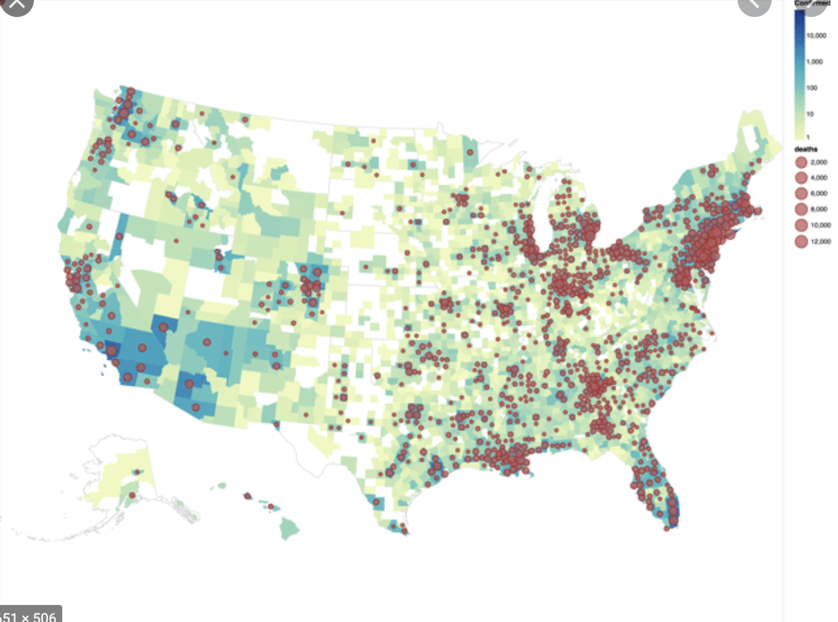

Figure 5: Choropleth map of coronavirus cases and deaths

A more popular way of representing the geodata of the covid-19 cases, is by using a choropleth map as shown below by the databricks page [14]. The choropleth heatmap is very intuitive compared to the cartogram, as it does not distort the geographical shape or size of the regions, but uses heatmap with colors to show the severity of the affected regions as depicted in Figure 5.. The above visualization goes one step further to also show the number of deaths using circle sizes to represent the severity of deaths in various regions. This visualization suffers from the drawback of not clearly showing the number of cases especially for smaller regions like NY, as the mortality data shadows the cases information.

The work done by the viewsoftheworld webpage [15] tries to strike a balance between the cartogram approach and the choropleth approach by drawing them side by side to produce the combined effect as shown below in Figure 6.

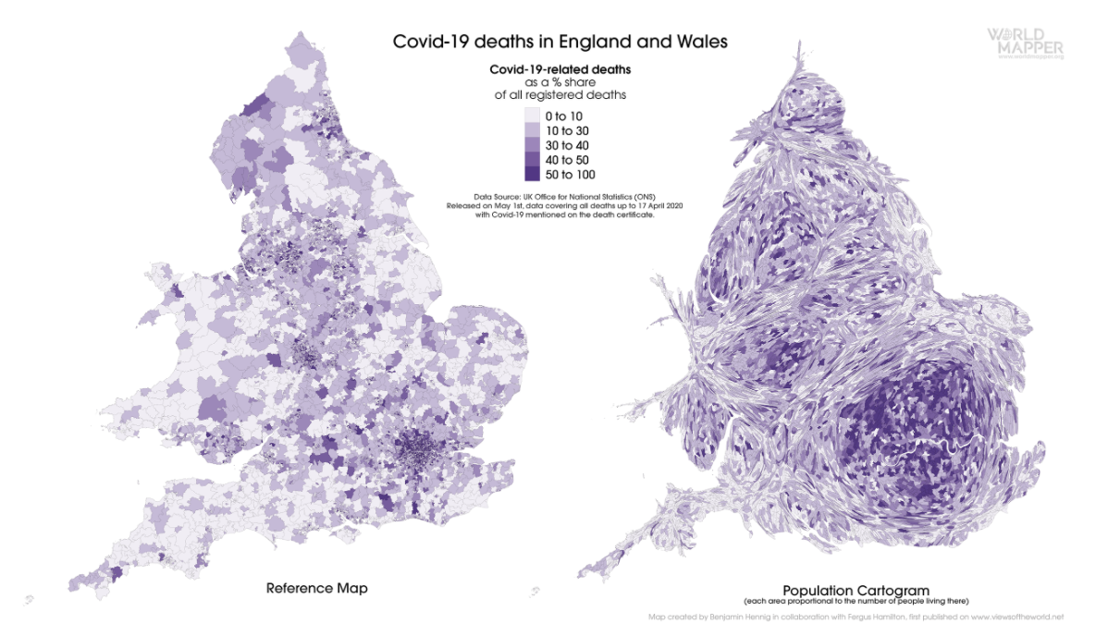

Figure 6: Covid 19 deaths in England and Wales

This is a nice hybrid approach of combining two effective visualization techniques to show the covid cases relative to the population, but the drawback is again the effort required from the viewer to combine the above two maps to understand the severity of cases in various regions.

Another interesting work on visualizing covid data using cartograms is by the work done in this paper [6] where they use the dorling cartogram to display the data effectively. This visualization is very effective in portraying the changes in the number of confirmed cases over a time period but suffers from the drawback that it sacrifices the geographical shape of the regions thereby not providing a very good representation of the underlying geographical region as shown in Figure 7.

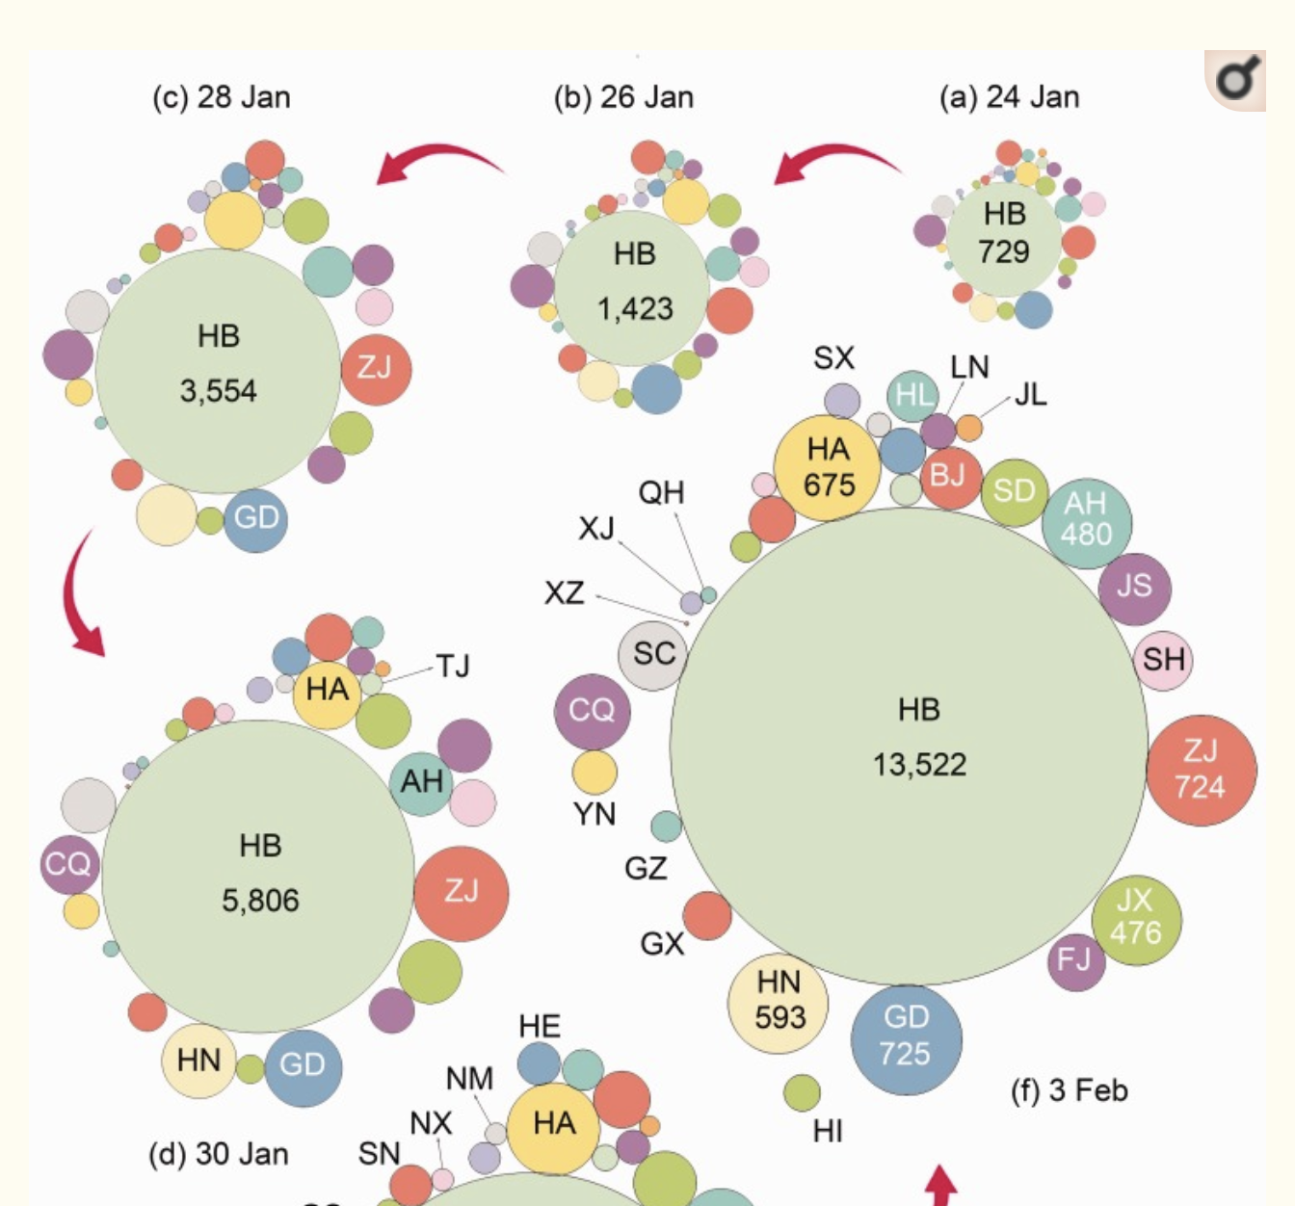

Figure 7: Dorling cartogram of Covid-19 cases in China

**Contribution**

The existing covid-19 visualizations using cartograms represent the data for the entire world and the size of the regions represent the population, and uses colors to represent either the current cases or the deaths. Our goal is to create a time lapse video of the cartograms for the US region, where both the number of cases and deaths can be unambiguously represented by using the number of cases to resize the size of each state and using sequential colors to represent the death rate. The result is a completely new visualization of the covid-19 pandemic in the US using cartograms effectively displaying both the number of cases and deaths in a completely new animation. In the process, we also develop time lapse animations using choropleth maps, non contiguous cartograms, univariate contiguous cartograms and bivariate contiguous cartograms.

In addition to the cartograms and the time lapse video of the US, we have also contributed to the underlying cartogram open source repository with a couple of fixes [16] and features [17]

# **Data and Methods**

The main dataset to visualize the spread of COVID-19, is from The New York Times Covid-19 and the tracking project provided comprehensively by the kaggle page [18]. This dataset is updated on a daily basis starting from the first case in January and has the data for the confirmed cases and deaths, number of recovered cases and data related to hospitalizations at state level. We also have used the dataset from NY times initially to produce the prototype time lapse video, considering the total number of cases alone [19]. We have also used the population data from [20], the color representation for US states from [21] and the GeoJSON file for Albers US map representation from [22].

The following Figure 8, shows the cleaned and processed main covid-19 table used for building the visualizations.

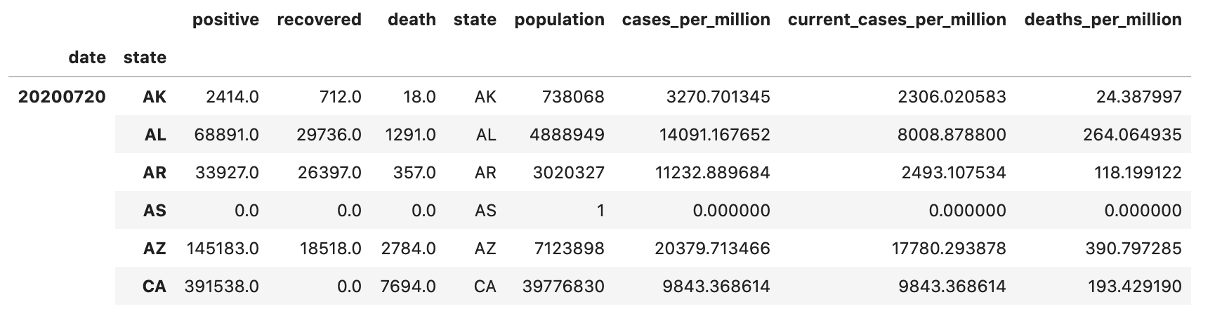

Figure 8: Us states daily covid-19 data

The table is indexed by date and state, for a particular date and state we have the set of positive cases, deaths, recovered cases in the base table. We calculate the number of current cases by subtracting the recovered cases from the positive cases. We then normalize the data for a standard per million population. Using the number of current cases directly does not show the severity of infection in a state, as a state with a high population will obviously have a high number of cases, hence the need for normalization using population arises.

The main idea with respect to the cartogram visualization is to produce a time lapse video of the time series data of covid-19 cases and deaths for the US region.

Our first idea was to use a sequence of choropleth images like the one in Figure 9, to create the time lapse video, and while the visualization created was pretty good, it suffered from the major drawback of being able to accentuate only one variable, either the confirmed cases or the number of deaths at a time. We wanted to do something better, a format more suited for the animation we had in mind. Another big drawback of using a choropleth map to time lapse video is the lack of continuity in the adjacent frames.

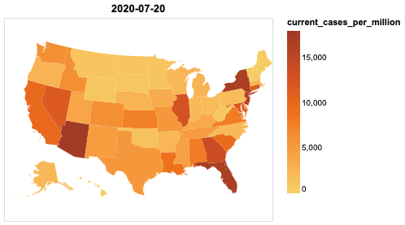

Figure 9: Choropleth viz of current cases as of July 20 2020.

As our next idea, we considered using the cartograms produced by the geoplot library that used a non-contiguous cartogram which is shown in the below visualization in Figure 10, that represented the confirmed cases by the size of each region. This produced a set of nice visualizations spread over time visualizing both the number of confirmed cases and the number of deaths in a single image, the time lapse video created could be made better in terms of the continuity of the frames generated.

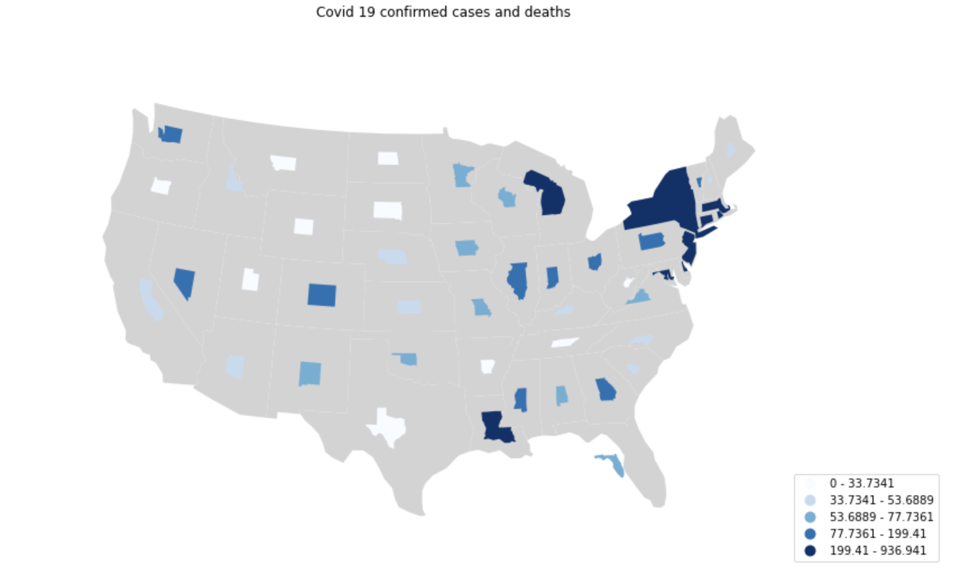

Figure 10: Non contiguous cartogram prototype of covid 19 cases and deaths

Our final approach was to use the idea from the work done in [4] to use diffusion based density equalizing cartogram technique [12] and get the cartogram closer to the representations below:

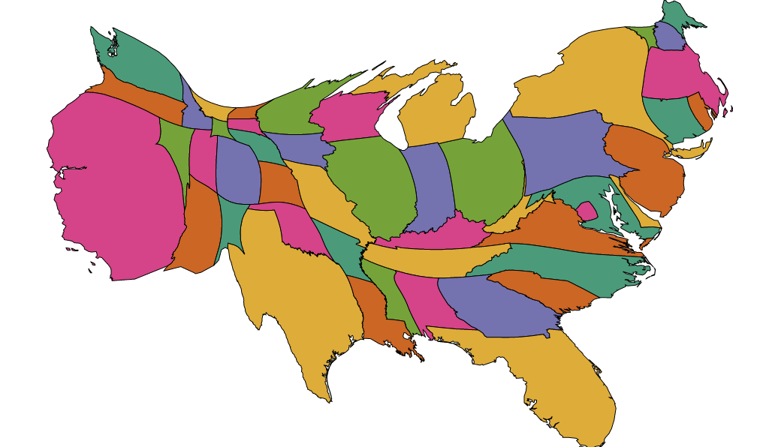

Figure 11: Contiguous cartogram prototype

Our first prototype time lapse video represents only the confirmed current cases without representing deaths and the colors simply representing the different states as shown in Figure 11.

Our goal for our final work is to produce cartograms where the size represented the number of current cases and the color representing the deaths, thereby producing visualizations similar to the one below in Figure 12, that can be visualized as a time lapse video displaying additional details like the worst affected states in terms of cases and deaths.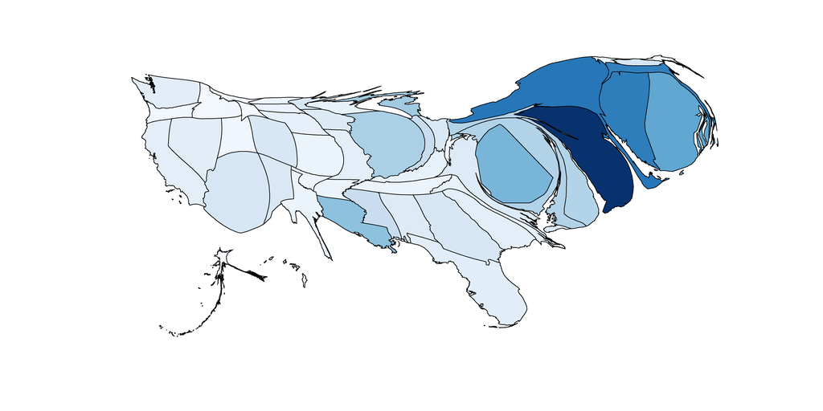

Figure 12: Contiguous cartogram prototype with sequential colors

# **Results**

### Choropleth time series

Our first set of visualizations uses a series of choropleth maps to understand the timeline of the coronavirus spread. By using the concept of small multiples, each frame in the visualization captures the number of current cases using choropleth heat maps, with a tooltip to display extra information on the number of deaths and the name of the state. Each frame corresponds to the state of the spread at the starting of the month.

The first set captures the time series by purely using the number of positive confirmed cases as shown in Figure 13.

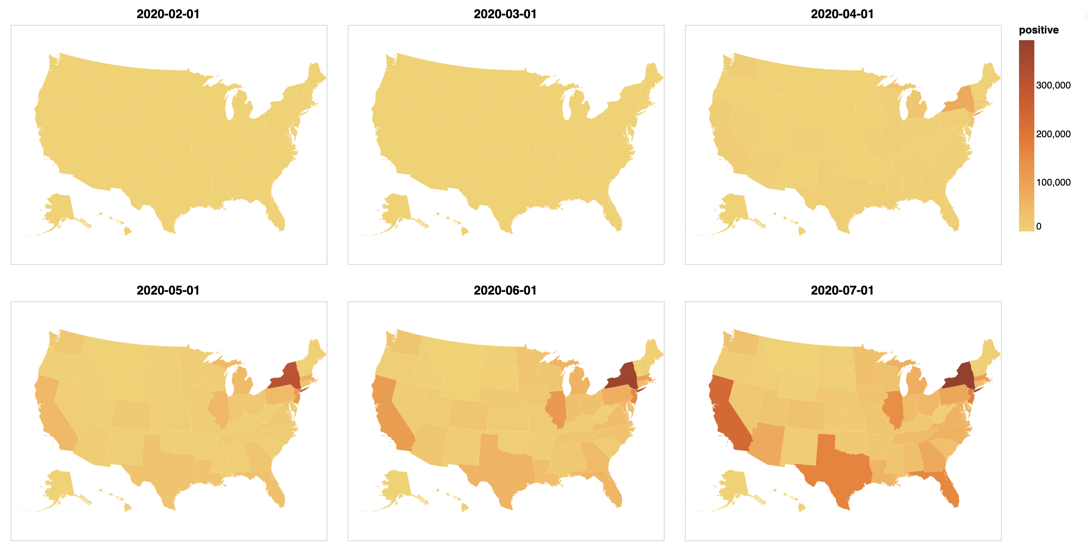

Figure 13: Time series (starting of each month) choropleth maps representing Covid-19 cases for the total number of positives so far.

As we can see clearly, the pandemic started in January/February time and the US was not affected much even in the beginning of March. Things started going downhill for the US from April, and we can clearly see NY heading the way, with Illinois, California, Michigan, Massachusetts, Texas and Florida starting to increase from May and continuing the trend till todate. Looking at the confirmed positive cases does not give an overall picture, as we have to take into account the number of recovered cases as well and additionally consider the population density of a region. Otherwise, larger states with higher populations will always show bigger numbers naturally. By normalizing the data per million we get the following time series charts that depict a more accurate picture of the spread as shown in Figure 14.

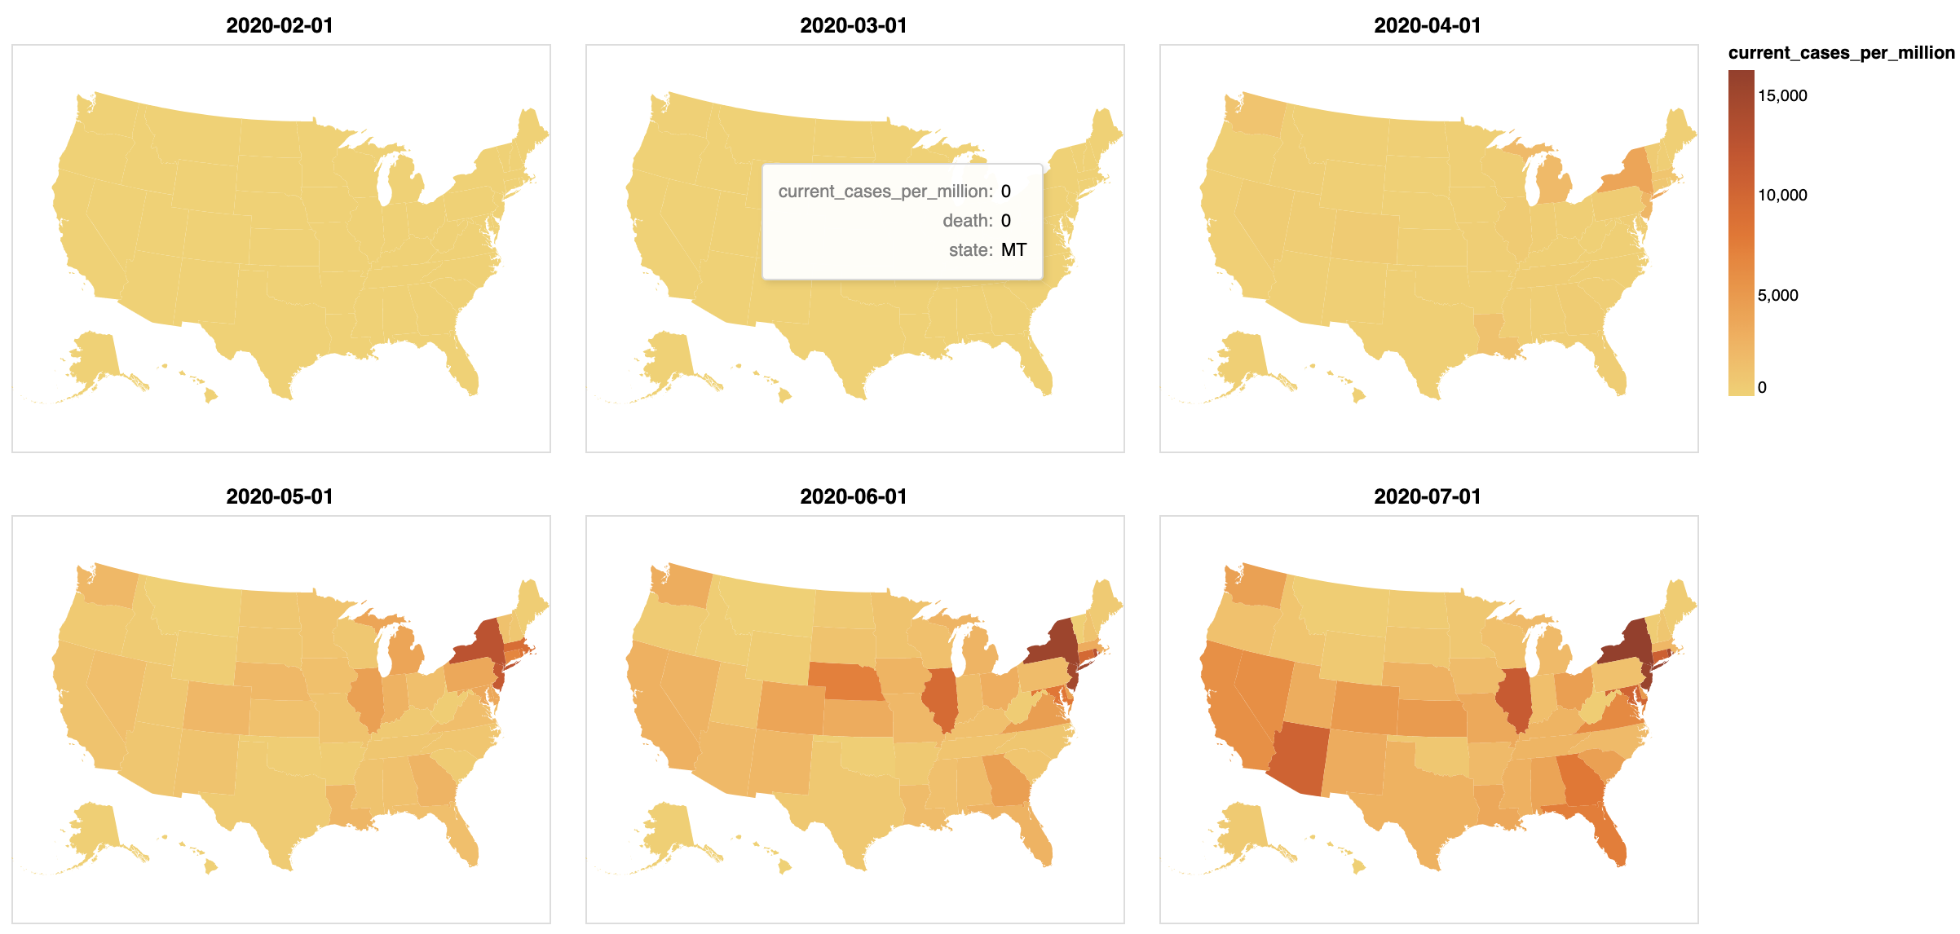

Figure 14: Time series (starting of each month) choropleth maps representing Covid-19 cases for current cases per million.

With the normalized data per million population shown above, we can clearly see that the midwest states also show up as being worsley affected starting from May and continuing the trend till date.

Since the above visualization only shows the number of cases, we have our last set in this series shown in Figure 15, that visualizes the number of deaths. The trend pretty much follows the number of cases, but also differs in where the deaths are concentrated more. One interesting observation is that Louisiana does not seem to have a very large number of cases, but has a high death rate. Another observation is that California has a relatively large number of cases, but seems to have a controlled death rate. NY and NJ appear to dominate both the number of cases and deaths.

The choropleth series gives a nice overview of the state of the coronavirus spread at different timelines, helping us to capture and understand the broad picture of how the virus spread. Since our ultimate goal is to create a timelapse video of the coronavirus spread, the following is a time lapse video of the animation: https://iu.mediaspace.kaltura.com/media/0_nvjolq9d

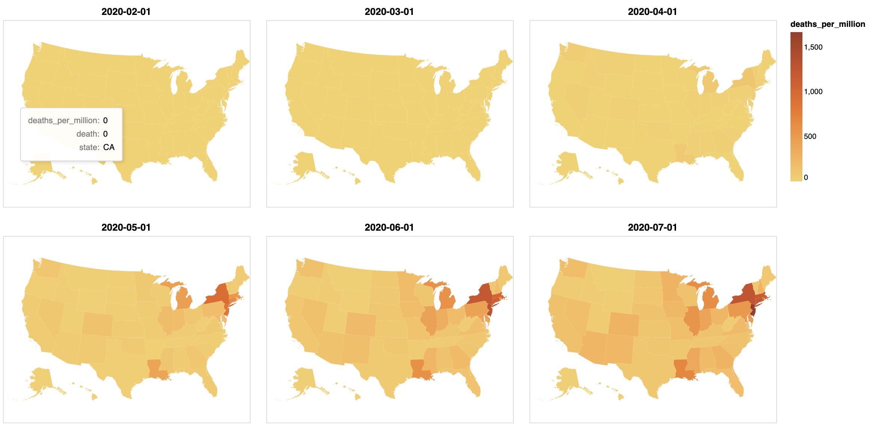

Figure 15: Time series (starting of each month) choropleth maps representing Covid-19 cases for the current number of deaths

As we observe the time lapse video of the choropleth maps, we can still see the evolution of the spread of the disease over time as the hue changes, but the change is not apparent. One quick observation here is that, the change in the main variable of interest which is the number of current cases is not very clearly portrayed and using choropleths, visualizing either cases or deaths one at a time gives good visualization, but if we need to visualize both, then we need to explore other options and we move on to see if we can use cartograms that emphasize our variable of interest, can produce better animation.

### Non contiguous Cartogram

The first type of cartogram we explore is a non contiguous cartogram that maintains the shape of the regions, but still emphasizes our variable of interest using distorted topology and object centroids. In these cartograms the features are not connected, but enlarge or shrink based on the variable of interest as shown in Figure 16.

|  |  |
| --- | --- |
|  |  |
|  |  |
|  |  |

Figure 16: Time series (starting of each month) non contiguous cartograms representing Covid-19 current cases and deaths

The above set of visualizations are produced by using the non contiguous cartogram method provided by the geopandas library. The size of the region represents the number of current cases and the color of the region represents the death rate. The beauty of these visualizations over the choropleth is the ability to represent both the number of cases and the deaths in a geo visualization unambiguously.

The cartogram gives us a ton of visual insights not immediately obvious in the choropleth maps. The fact that Washington state was the origin of the pandemic in the US, is so clearly visible in the cartogram visualization. Also since the number of cases is represented by the size of the region, we can see Washington state shrink back starting from April as other regions begin to grow. The biggest strength of the visualization is its ability to portray the evolution of both the number of cases and the deaths effectively. The main drawback of this visualization, especially in the context of a time lapse video, is its non contiguous nature, which hinders the smooth flow of frames to some extent. The time lapse video can be viewed at the following link https://iu.mediaspace.kaltura.com/media/0_dddw921h

### Contiguous cartogram univariate

Moving on, in the quest to create a more seamless flow in a time lapsed video, we continue to explore the option of using a contiguous cartogram technique. A contiguous cartogram preserves the topology of the underlying regions at the cost of distorting the shape. We use a diffusion based density equalizing cartogram technique based on the cartogram program written by Michael Gastner [23]. The first major challenge was to install the software itself as the program failed to install. After talking to Michael Gastner on this, it was clear that he himself faces this issue in the current version of Mac OS and as a first step we went to fix this and contribute to the open source software [16] to make the necessary C code changes to get the program running. This fix is already integrated and committed into open source. The second major hurdle from the cartogram program came from the inability of the underlying program to draw different regions with varying colors and the only color supported for all regions was yellow. To address this, we enabled accepting color parameters as input for regions and made the necessary C code changes [17] in the cartogram program to make this work and we are in the process of submitting this as our second contribution to the underlying open source software.

Once past these hurdles, then we were able to get the visualizations done, with the first set representing the number of cases using the size of the regions and the color used simply to distinguish the different states of the US. The result was a stunning display of how contiguous cartogram distorts the shape of the underlying region but effectively accentuates the underlying variable it represents, in this instance the number of current cases as shown in Figure 17. As we look at the time series visualizations, it is evident that in the starting of February, Washington is the only state that has confirmed cases of the coronavirus. Even by early March, Washington, Michigan and Rhode Island register a few cases as the total number of cases in the US is below 400. The cartogram very clearly depicts this so nicely by dedicating the entire land region of the US to draw these states with positive cases.

But as the time series progresses, we can observe that by the beginning of April, the pandemic has spread to all the states of the US and the cartogram depicts this perfectly as the land region of the US is distributed across all the states, in proportion to the number of cases they have per Million. It is also obvious that Washington has its cases well under control by this time, as it is no more in the top 3 worst affected states. The trend observed from April to May, shows that the number of cases have quadrupled, as more and more states that were a late entry into the picture start having an increase in their number of cases. Also, the April and May cartograms clearly show how the east and southern parts of the US are prominently becoming the major source of rapid spread of the virus, as the western region seems to have a more controlled spread and a smaller proportion of the cases. This is even more evident in May with the midwest also becoming more prominent along with the eastern and southern states occupying the bulk share of the cases as depicted by the cartogram. From May to June, we see that the number of cases have doubled, but the shape of the states of the map almost follow a similar pattern indicating that the cases are rising in a similar manner in June as in May. From June to July, we see that California, Arizona, Florida and Texas seem to balloon up in their cases as depicted in the cartogram and this coincides with the initial phases of the opening up of the different states to parts of their economies and these were the states that has most impact to the reopening of their economy.

For additional clarity, in each cartogram, we also display the time series for the previous, current and next day total number of cases and deaths and also the top 3 worst affected states in total numbers and in normalized per million numbers.

As we can clearly see, the set of cartograms depict a nice picture of the state of the coronavirus spread during different timelines of the pandemic, and by modifying the size of the region in proportion to the number of cases, the visualization is effective in depicting the time series data with an emphasis on the number of cases. The main drawback of this set of visualizations is the inability to represent the number of deaths in the map, alongside the number of cases. Also since the shape is distorted, it is difficult to identify some of the states, unless one is familiar with the color scheme used.

The time lapse video for the univariate contiguous cartogram can be viewed at the following link https://iu.mediaspace.kaltura.com/media/0_whv0zcui . As we observe the time lapse video, this one is much smoother than the one we had from the non contiguous cartogram. The flow seems to be natural from frame to frame and we get the visualization story that we were aspiring for.

|  |  |
| --- | --- |
|  |  |
|  |  |
|  |  |

Figure 17: Time series (starting of each month) contiguous cartograms representing Covid-19 current cases using categorical colors for states.

### Contiguous cartogram bivariate

The final idea in our visualization series, is to use both the number of cases and the number of deaths using a contiguous cartogram technique. In these set of visualizations, everything remains the same with respect to the previous set of visualizations, except the color scheme. Instead of assigning fixed colors to each state, now the color is assigned based on the number of deaths per million.

The story depicted in these visualizations holds exactly similar to the previous one, but in addition we get new insights related to the number of deaths. As the cartograms show, until the beginning of April, the total number of deaths across the US is relatively low, in the order of few hundreds. But by the time April arrives, the number of deaths increase closer to 5k, spread all over the country, as visible in the light red hue spread across the country. The big increase in the number of deaths happens in April as we see in the transition from April to May, we can observe NY, NJ and CT becoming darker and the deaths have ballooned up by 10x. As observed in the total number of cases, the East once again dominates the map with respect to the number of deaths per million. The cartograms also depict the rise of New Jersey in dominating the number of deaths in the last 3 months.

The time lapse video for the bivariate contiguous cartogram can be viewed at the following link https://iu.mediaspace.kaltura.com/media/0_hwrb4fkp . As in the previous case, the time lapse video has a smoother flow, beautifully depicting the number of cases and deaths over time, by visually clear and observable change in hues and sizes of the different states over a period of time.

|  |  |
| --- | --- |
|  |  |
|  |  |
|  |  |

Figure 18: Time series (starting of each month) contiguous cartograms representing Covid-19 current cases and deaths using sequential colors for death.

# 

# **Conclusion and Future Work**

We started this journey of creating a geo time series of visualizations relating to the spread of the coronavirus to ultimately end with a goal of producing nice animations using time lapse videos. The initial experiments were done using choropleth maps, and though producing stunning visuals, the choropleth approach had two main misgivings, one to do with displaying cases and deaths simultaneously and the other to do with the natural flow of the time lapse video. We moved on to using non contiguous cartograms, producing time series visualizations and time lapsed video capturing both the number of cases and deaths of the coronavirus spread, suffering from the only drawback that the non contiguous nature could be improved to be more suitable for the time lapsed animation. Our next approach resulted in using density equalizing cartograms with the first series focusing only on the number of cases and producing a stunning set of visualizations and time lapsed animation, and we moved on to improve this approach by using sequential colors to represent the deaths as well, thereby resulting in visuals and time lapsed video neatly portraying the cases and deaths. The one major drawback of the cartogram approaches is the resulting distortion in shape, which makes it harder to identify individual regions clearly, without the viewer having to put in some effort to create a mental image of the original map or by constantly referring back to the non distorted version.

One experiment that failed in our approach, was trying to find the intermediate frames given two frames at t1 and t2. The idea behind this, is to get a much more smoother visualization by using linear interpolation and we used the technique as described in [24], but using the Image.blend function from the PIL library did not work for our images as we could see the shadow of the images in the in between frames and we need to find a better way of doing the linear interpolation using the Geo Json data directly and by using the svg format of the images.

Also, more work can be done in the underlying cartogram program itself to display the state names in the visuals to make it easy on the viewers to identify the regions. So far, this has not been done in the available non contiguous and contiguous cartogram libraries and this will be an interesting undertaking for the future.

Our work is available at **<INSERT GITHUB LINK HERE>**

# 

# 

# **References**

[1] <https://www.cdc.gov/coronavirus/2019-ncov/covid-data/data-visualization.htm>

[2] <https://informationisbeautiful.net/visualizations/covid-19-coronavirus-infographic-datapack/>

[3] S. Nusrat, M. J. Alam and S. Kobourov, "Evaluating Cartogram Effectiveness," in IEEE Transactions on Visualization and Computer Graphics, vol. 24, no. 2, pp. 1077-1090, 1 Feb. 2018, doi: 10.1109/TVCG.2016.2642109.

[4] <https://mislove.org/twittermood/>

[5] <http://www-personal.umich.edu/~mejn/election/2012/>

[6] Gao, P, Zhang, H, Wu, Z, et al. (2020) Visualising the expansion and spread of coronavirus disease 2019 by cartograms. *Environment and Planning A: Economy and Space*. Epub ahead of print 26 February 2020. DOI: 10.1177/0308518X20910162.

[7] <https://worldmapper.org/covid-19-coronavirus/>

[8] <https://www.nytimes.com/interactive/2020/us/coronavirus-us-cases.html>

[9] <https://coronavirus.jhu.edu/data>

[10] <https://www.arcgis.com/home/item.html?id=4b8c9ce99a5749e298bb96366692f35d>

[11] <http://www.ncgia.ucsb.edu/projects/Cartogram_Central/types.html>

[12] Michael T. Gastner, M. E. J. Newman "Diffusion-based method for producing density-equalizing maps" in Proceedings of the National Academy of Sciences May 2004, 101 (20) 7499-7504; DOI: 10.1073/pnas.0400280101

[13] <https://worldmapper.org/map-animation-covid19/>

[14] <https://databricks.com/blog/2020/04/14/covid-19-datasets-now-available-on-databricks.html>

[15] <http://www.viewsoftheworld.net/>

[16] <https://github.com/Flow-Based-Cartograms/go_cart/commit/2df3c5a9ef45aab5042de8a0407dbdaf988a0dfd>

[17] <https://github.com/johnyrufus/go_cart/commit/178fb5621c073ee012f7f5cbddc8997b8fb7998a>

[18] <https://www.kaggle.com/sudalairajkumar/covid19-in-usa?select=us_states_covid19_daily.csv>

[19] <https://github.com/nytimes/covid-19-data>

[20] <https://www.kaggle.com/lucasvictor/us-state-populations-2018/data>

[21] <https://go-cart.io/>

[22] <https://rstudio-pubs-static.s3.amazonaws.com/166138_681942e74efa4734bfe153e40760c566.html>

[23] [https://github.com/Flow-Based-Cartograms/go_cart/](https://github.com/Flow-Based-Cartograms/go_cart/commit/2df3c5a9ef45aab5042de8a0407dbdaf988a0dfd)

[24] https://github.com/spodzone/timelapse.py/blob/master/interpimage.py